**DDL**

create database Company;

use Company;

CREATE TABLE EMPLOYEE (

Fname VARCHAR(50),

Minit CHAR(1),

Lname VARCHAR(50),

Ssn CHAR(9) PRIMARY KEY,

Bdate DATE,

Address VARCHAR(100),

Sex CHAR(1),

Salary DECIMAL(10,2),

Super_ssn CHAR(9),

Dno INT,

FOREIGN KEY (Super_ssn) REFERENCES EMPLOYEE(Ssn),

FOREIGN KEY (Dno) REFERENCES DEPARTMENT(Dnumber)

);

INSERT INTO EMPLOYEE (Fname, Minit, Lname, Ssn, Bdate, Address, Sex, Salary, Super_ssn, Dno)

VALUES ('James', 'E', 'Borg', '888665555', '1937-11-10', '450 Stone, Houston, TX', 'M', 55000, NULL, 1);

INSERT INTO EMPLOYEE (Fname, Minit, Lname, Ssn, Bdate, Address, Sex, Salary, Super_ssn, Dno)

VALUES ('Franklin', 'T', 'Wong', '333445555', '1955-12-08', '638 Voss, Houston, TX', 'M', 40000, '888665555', 5);

INSERT INTO EMPLOYEE (Fname, Minit, Lname, Ssn, Bdate, Address, Sex, Salary, Super_ssn, Dno)

VALUES ('Jennifer', 'S', 'Wallace', '987654321', '1941-06-20', '291 Berry, Bellaire, TX', 'F', 43000, '888665555', 4);

INSERT INTO EMPLOYEE (Fname, Minit, Lname, Ssn, Bdate, Address, Sex, Salary, Super_ssn, Dno)

VALUES

('John', 'B', 'Smith', '123456789', '1965-01-09', '731 Fondren, Houston, TX', 'M', 30000, '333445555', 5),

('Ramesh', 'K', 'Narayan', '666884444', '1962-09-15', '975 Fire Oak, Humble, TX', 'M', 38000, '333445555', 5),

('Joyce', 'A', 'English', '453453453', '1972-07-31', '5631 Rice, Houston, TX', 'F', 25000, '333445555', 5),

('Alicia', 'J', 'Zelaya', '999887777', '1968-01-19', '3321 Castle, Spring, TX', 'F', 25000, '987654321', 4),

('Ahmad', 'V', 'Jabbar', '987987987', '1969-03-29', '980 Dallas, Houston, TX', 'M', 25000, '987654321', 4);

CREATE TABLE DEPARTMENT (

Dname VARCHAR(50),

Dnumber INT PRIMARY KEY,

Mgr_ssn CHAR(9),

Mgr_start_date DATE

);

INSERT INTO DEPARTMENT (Dname, Dnumber, Mgr_ssn, Mgr_start_date) VALUES

('Research', 5, '333445555', '1988-05-22'),

('Administration', 4, '987654321', '1995-01-01'),

('Headquarters', 1, '888665555', '1981-06-19');

CREATE TABLE DEPT_LOCATIONS (

Dnumber INT,

Dlocation VARCHAR(50),

FOREIGN KEY (Dnumber) REFERENCES DEPARTMENT(Dnumber)

);

INSERT INTO DEPT_LOCATIONS (Dnumber, Dlocation) VALUES

(1, 'Houston'),

(4, 'Stafford'),

(5, 'Bellaire'),

(5, 'Sugarland'),

(5, 'Houston');

CREATE TABLE PROJECT (

Pname VARCHAR(50),

Pnumber INT PRIMARY KEY,

Plocation VARCHAR(50),

Dnum INT,

FOREIGN KEY (Dnum) REFERENCES DEPARTMENT(Dnumber)

);

INSERT INTO PROJECT (Pname, Pnumber, Plocation, Dnum) VALUES

('ProductX', 1, 'Bellaire', 5),

('ProductY', 2, 'Sugarland', 5),

('ProductZ', 3, 'Houston', 5),

('Computerization', 10, 'Stafford', 4),

('Reorganization', 20, 'Houston', 1),

('Newbenefits', 30, 'Stafford', 4);

CREATE TABLE WORKS_ON (

Essn CHAR(9),

Pno INT,

Hours DECIMAL(5,2),

FOREIGN KEY (Essn) REFERENCES EMPLOYEE(Ssn),

FOREIGN KEY (Pno) REFERENCES PROJECT(Pnumber)

);

INSERT INTO WORKS_ON (Essn, Pno, Hours) VALUES

('123456789', 1, 32.5),

('123456789', 2, 7.5),

('666884444', 3, 40.0),

('453453453', 1, 20.0),

('453453453', 2, 20.0),

('333445555', 2, 10.0),

('333445555', 3, 10.0),

('333445555', 10, 10.0),

('333445555', 20, 10.0),

('999887777', 30, 30.0),

('999887777', 10, 10.0),

('987987987', 10, 35.0),

('987987987', 30, 5.0),

('987654321', 30, 20.0),

('987654321', 20, 15.0),

('888665555', 20, NULL);

CREATE TABLE DEPENDENT (

Essn CHAR(9),

Dependent_name VARCHAR(50),

Sex CHAR(1),

Bdate DATE,

Relationship VARCHAR(50),

PRIMARY KEY (Essn, Dependent_name),

FOREIGN KEY (Essn) REFERENCES EMPLOYEE(Ssn)

);

INSERT INTO DEPENDENT (Essn, Dependent_name, Sex, Bdate, Relationship) VALUES

('333445555', 'Alice', 'F', '1986-04-05', 'Daughter'),

('333445555', 'Theodore', 'M', '1983-10-25', 'Son'),

('333445555', 'Joy', 'F', '1958-05-03', 'Spouse'),

('987654321', 'Abner', 'M', '1942-02-28', 'Spouse'),

('123456789', 'Michael', 'M', '1988-01-04', 'Son'),

('123456789', 'Alice', 'F', '1988-12-30', 'Daughter'),

('123456789', 'Elizabeth', 'F', '1967-05-05', 'Spouse');

**----PART B----**

**Write SQL and Relational Algebra statements for the following:**

1. **Show the details of the male employees who do not work for Dept #5.**

**Solution:**  
SELECT*FROM EMPLOYEE WHERE Sex='M' AND Dno<>5;

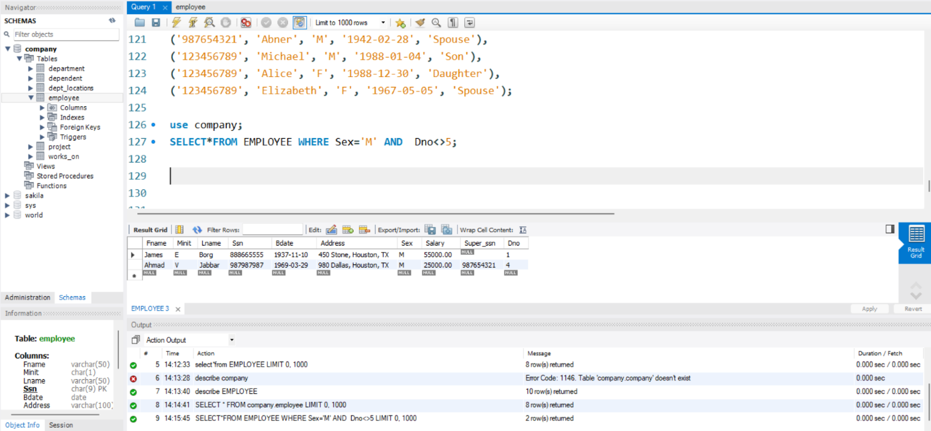

1. **Show the details of the projects being run under Dept #5.**

SELECT*FROM PROJECT WHERE Dnum=5;

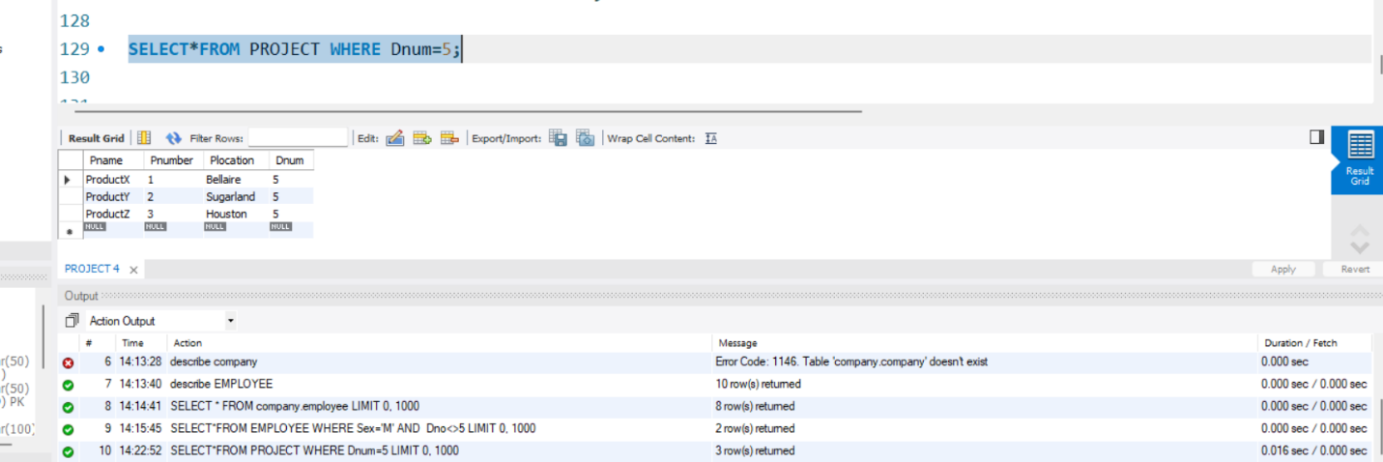

1. **Show the details of all the daughters**.

SELECT*FROM DEPENDENT WHERE Relationship ='Daughter';

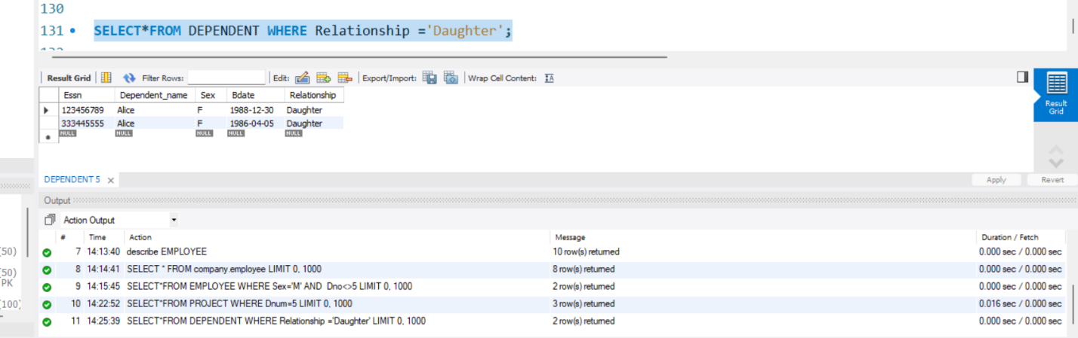

1. **Show the details of all dependents and all column names have the word UCP appended to them.**

SELECT Essn AS EssnUCP,

Dependent_name AS Dependent_nameUCP,

Sex AS SexUCP,

Bdate AS BdateUCP,

Relationship AS RelationshipUCP

FROM DEPENDENT;

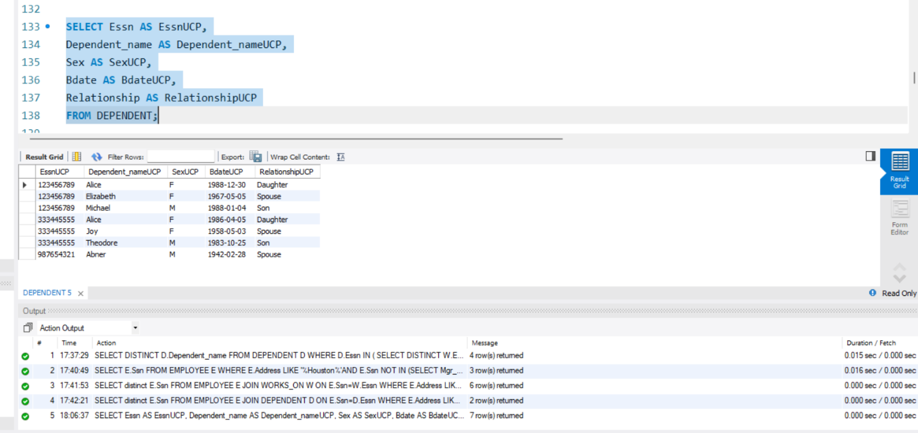

1. **Show the combinations of genders and salaries offered by the company.**

SELECT distinct Sex,Salary FROM EMPLOYEE;

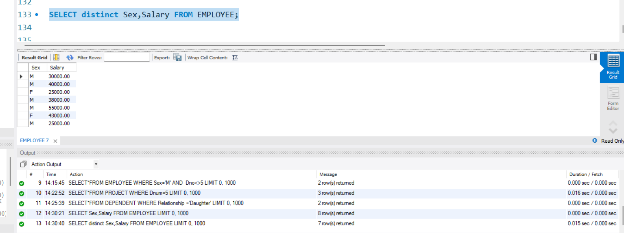

1. **Show the names and salaries of the female employees.**

SELECT Fname,Lname,Salary FROM EMPLOYEE where Sex='F';

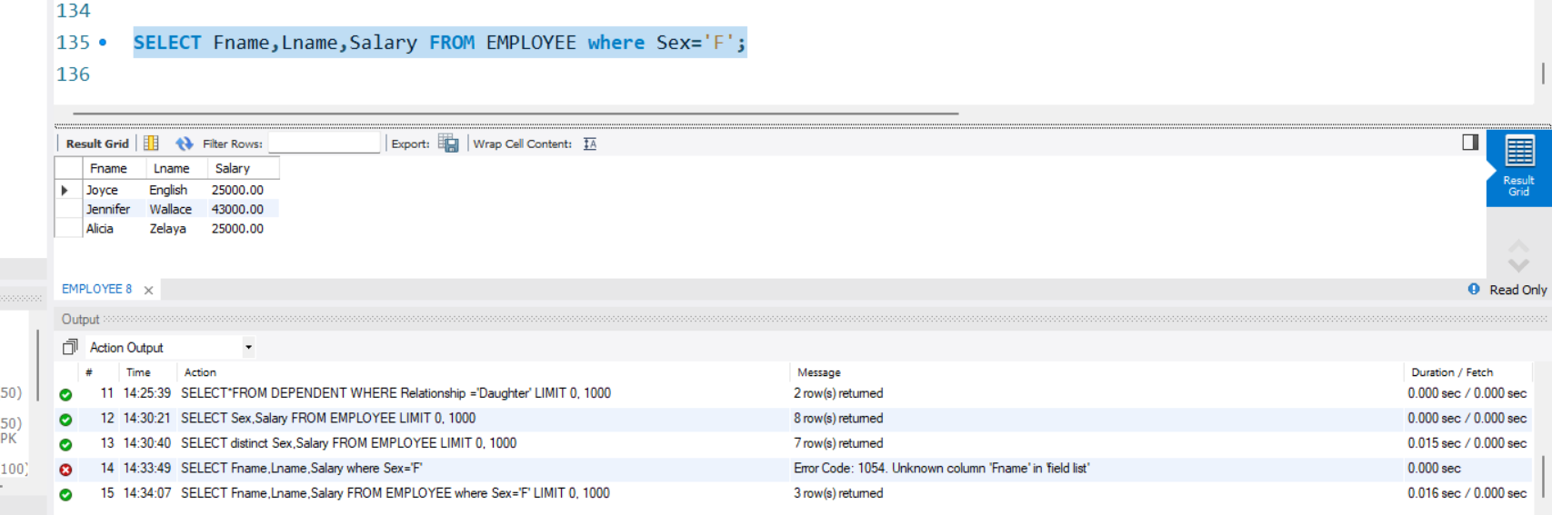

1. **Show the names and genders of the employees working in Dept #4 and earn less than 30K.**

SELECT Fname,Lname,Sex FROM EMPLOYEE WHERE Dno='4' AND Salary < 30000;

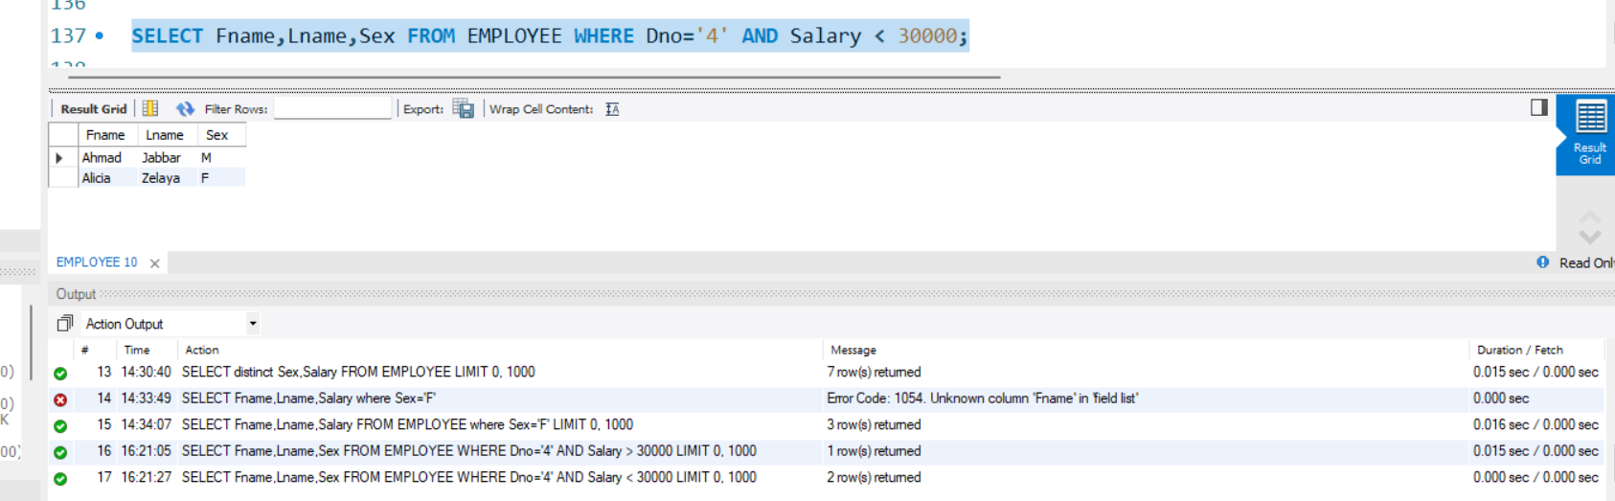

1. **Show the names and relationships of the dependents of employee #123456789**

SELECT Dependent_name,Relationship FROM DEPENDENT WHERE Essn='123456789';

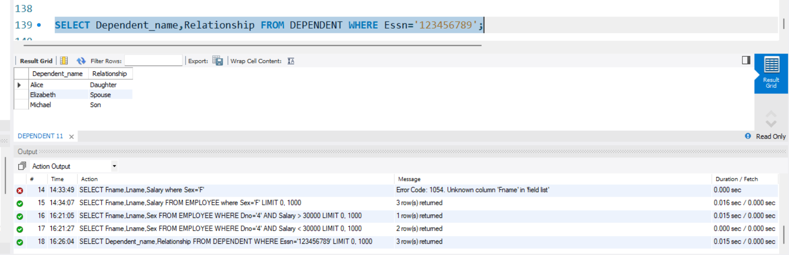

1. **Show the details of the male employees who earn more than 30K but less than 50K**

SELECT * FROM EMPLOYEE where Sex='M' AND Salary between 30001 AND 49999;

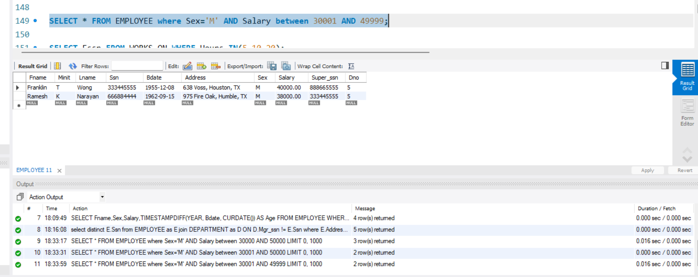

1. **Show the ids of the employees who spent 10 hours or 20 hours or 5 hours on any project.**

SELECT Essn FROM WORKS_ON WHERE Hours IN(5,10,20);

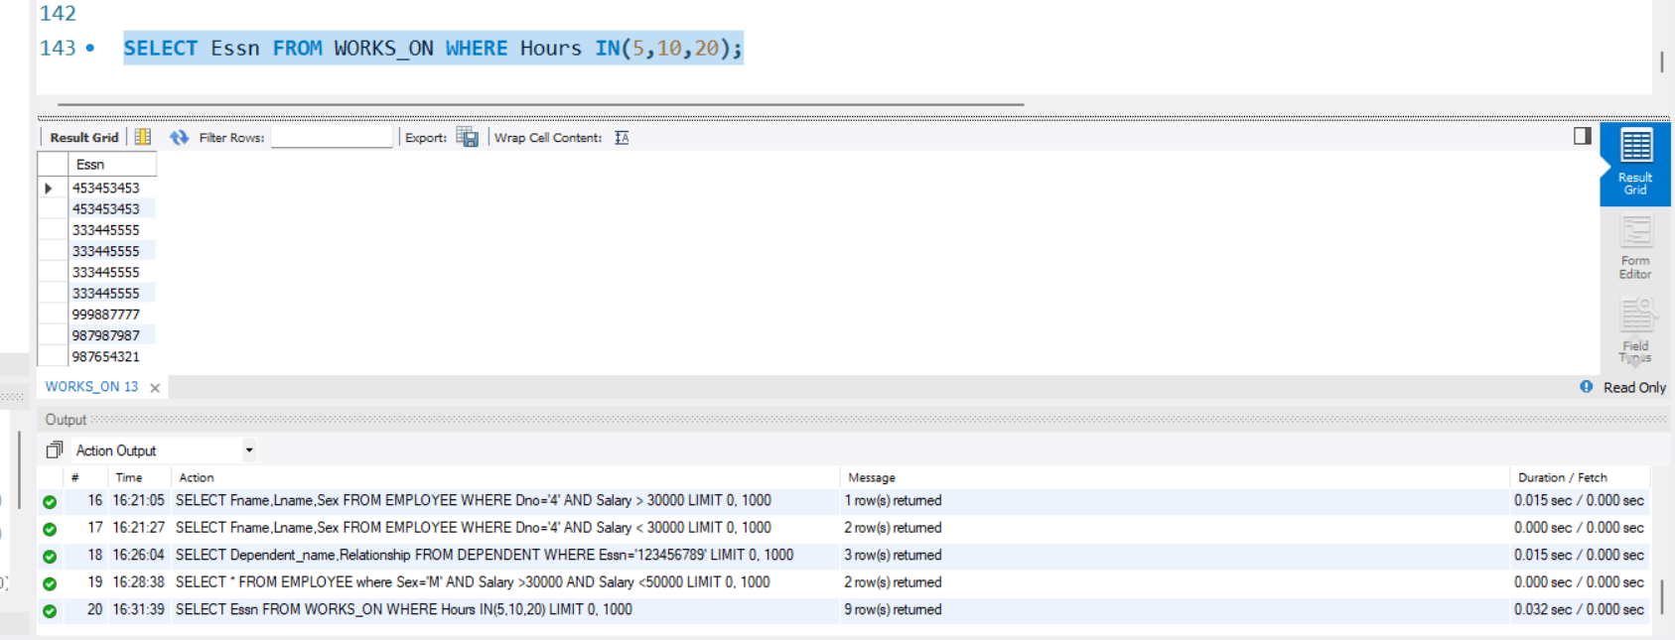

1. **Show the details of the employees who are supervised by either 3334445555 or 987654321.**

SELECT * FROM EMPLOYEE where Super_ssn IN('3334445555','987654321');

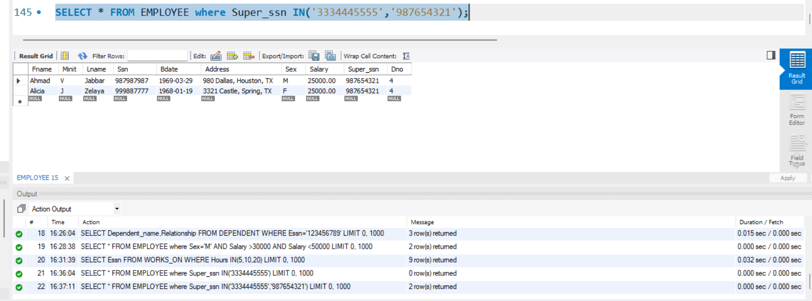

1. **Show the names, salaries and addresses of the employees who do not have any supervisor.**

SELECT Fname,Lname,Salary,Address FROM EMPLOYEE WHERE Super_ssn IS NULL;

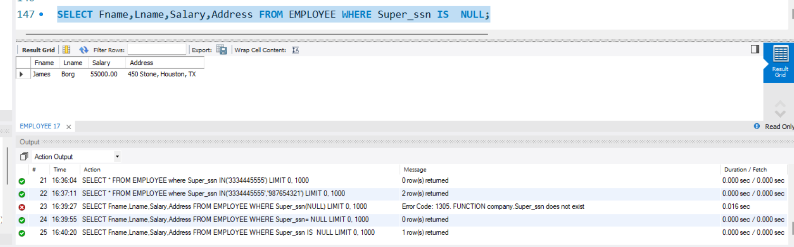

1. **Show the names and genders of the dependents who were born in May of any year.**

select Dependent_name,Sex FROM DEPENDENT WHERE Bdate LIKE '____-03-__';

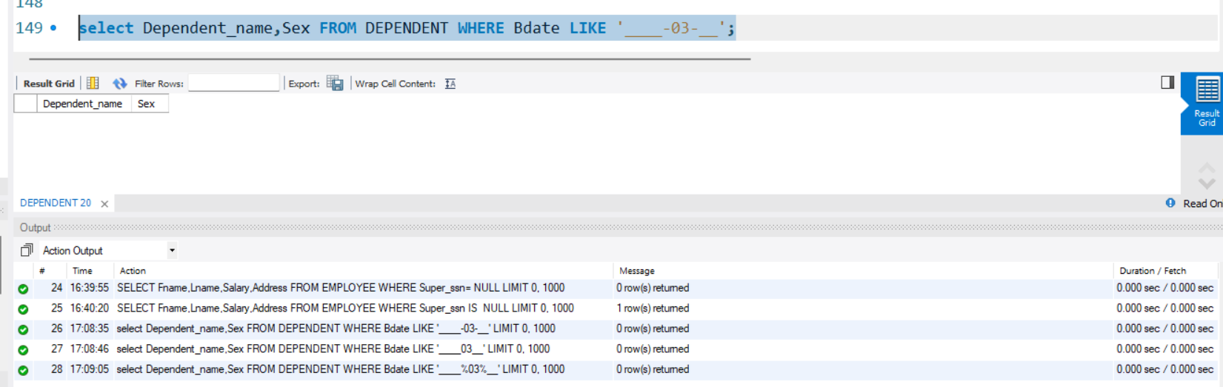

1. **Show the names and salaries of the employees who do not live in Houston.**

SELECT Fname,Lname,Salary FROM EMPLOYEE WHERE Address LIKE '%Houston,%';

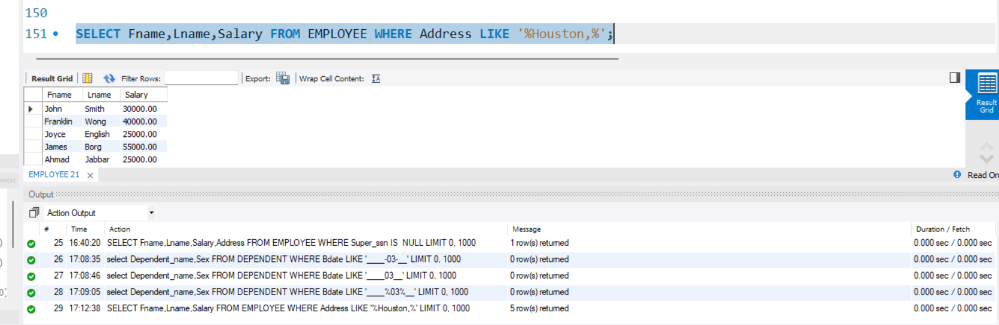

1. **Show the names and gender of the employees whose first name contains 2 n’s but double n’s are not allowed.**

SELECT Fname,Lname,Sex FROM EMPLOYEE WHERE Fname LIKE '%N_%N%';

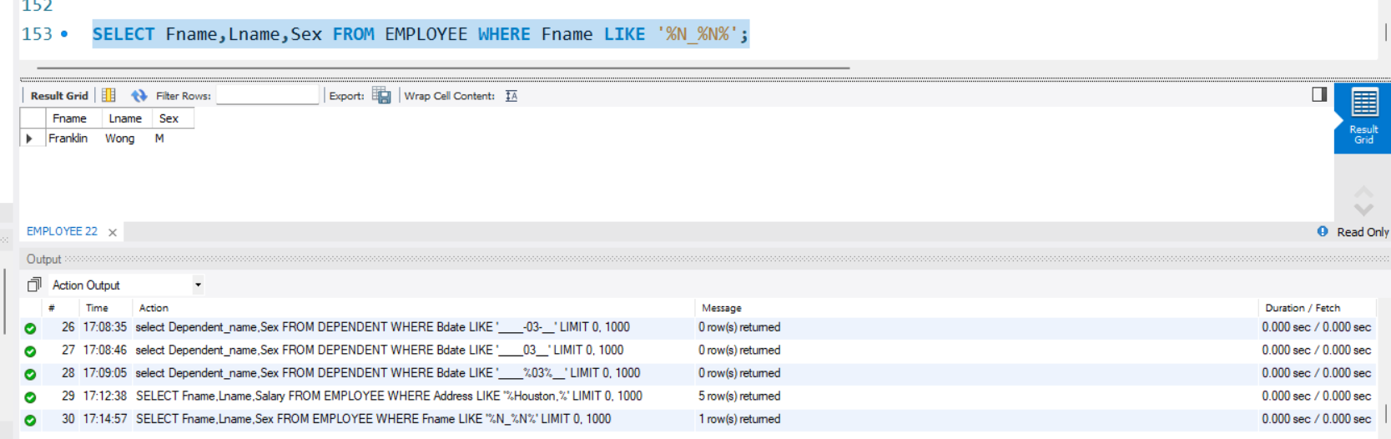

1. **Show the name and salaries of the employees whose first name start with ‘J’ or their last name has more than 5 characters.**

SELECT Fname,Lname,Salary FROM EMPLOYEE WHERE Fname LIKE 'J%' OR Lname LIKE '______';

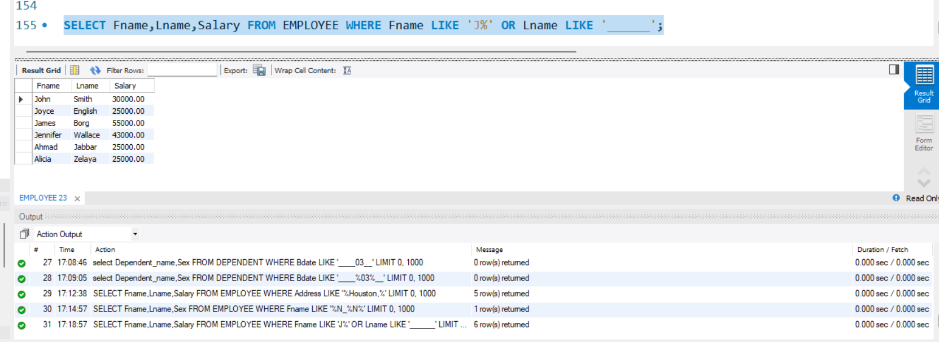

1. **Show the details of the dependents whose name start with ‘A’**

SELECT * FROM DEPENDENT WHERE Dependent_name LIKE 'A%';

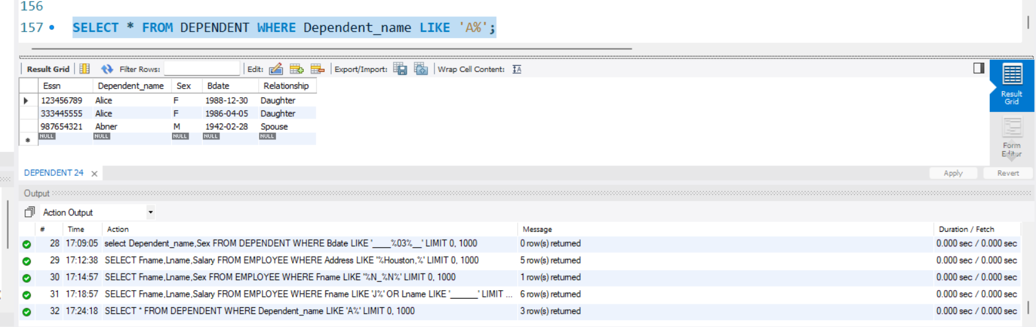

1. **Show the names, genders, salaries and current age of all employees of Dept# 5 in years.**

SELECT Fname,Sex,Salary,TIMESTAMPDIFF(YEAR, Bdate, CURDATE()) AS Age FROM EMPLOYEE WHERE Dno = 5;

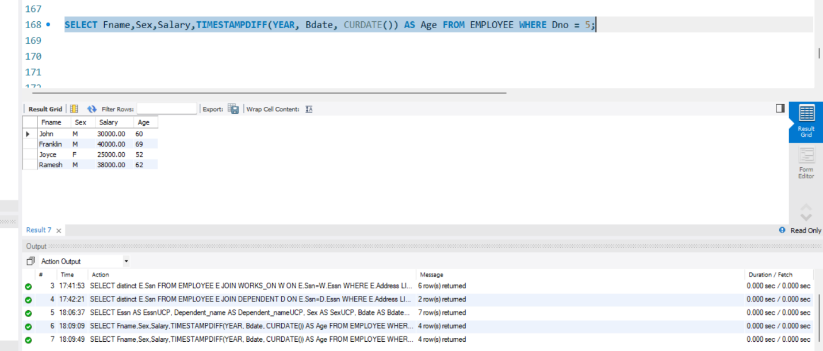

1. **Show the details of the employees whose full name contain 2 ‘n’s.**

SELECT * FROM EMPLOYEE where Fname LIKE '%N%N%'OR Lname LIKE '%N%N%' ;

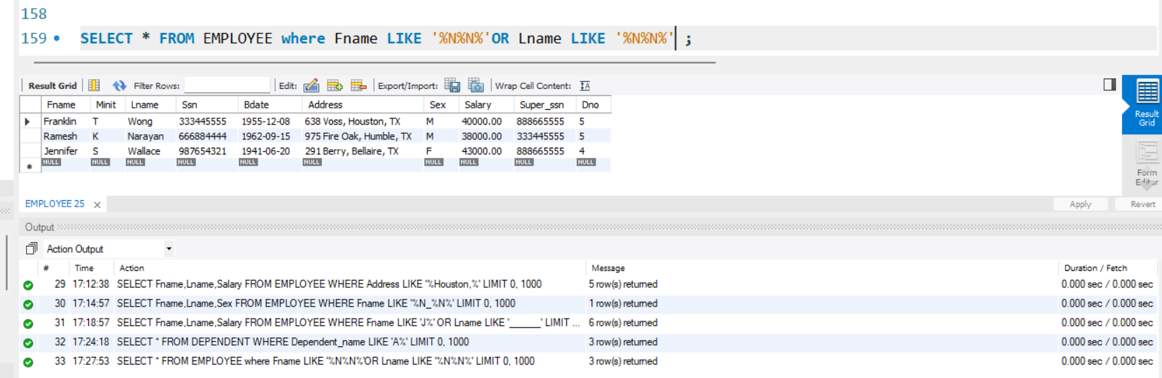

1. **Show the ids of the people who live in Houston or work on project # 10.**

SELECT distinct E.Ssn FROM EMPLOYEE E JOIN WORKS_ON W ON E.Ssn=W.Essn WHERE E.Address LIKE '%Houston,%' OR W.Pno=10;

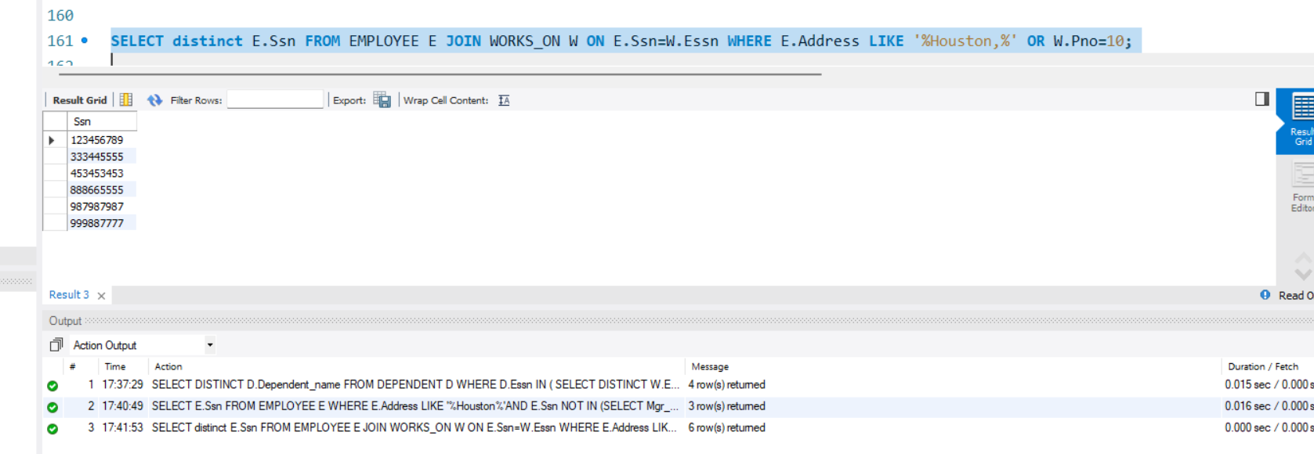

1. **Show the ids of the employees who live in Houston and have a female dependent.**

SELECT distinct E.Ssn FROM EMPLOYEE E JOIN DEPENDENT D ON E.Ssn=D.Essn WHERE E.Address LIKE '%Houston,%' AND D.Sex='F';

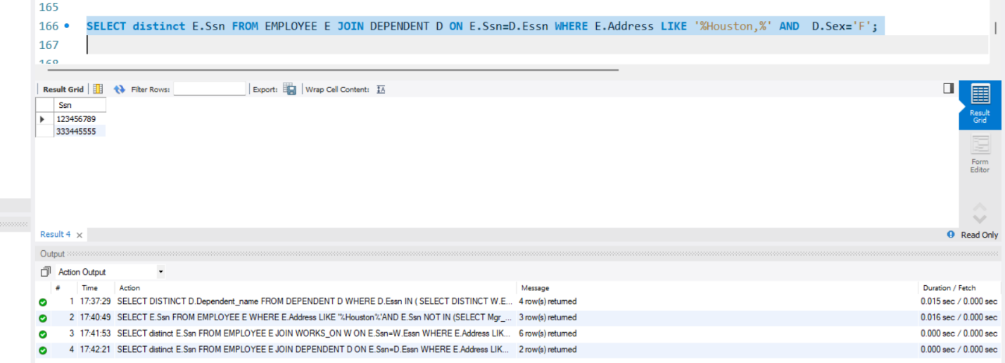

1. **Show the ids of the employees who live in Houston but are not managing any departments.**

SELECT E.Ssn FROM EMPLOYEE E WHERE E.Address LIKE '%Houston%'AND E.Ssn NOT IN (SELECT Mgr_ssn FROM DEPARTMENT);

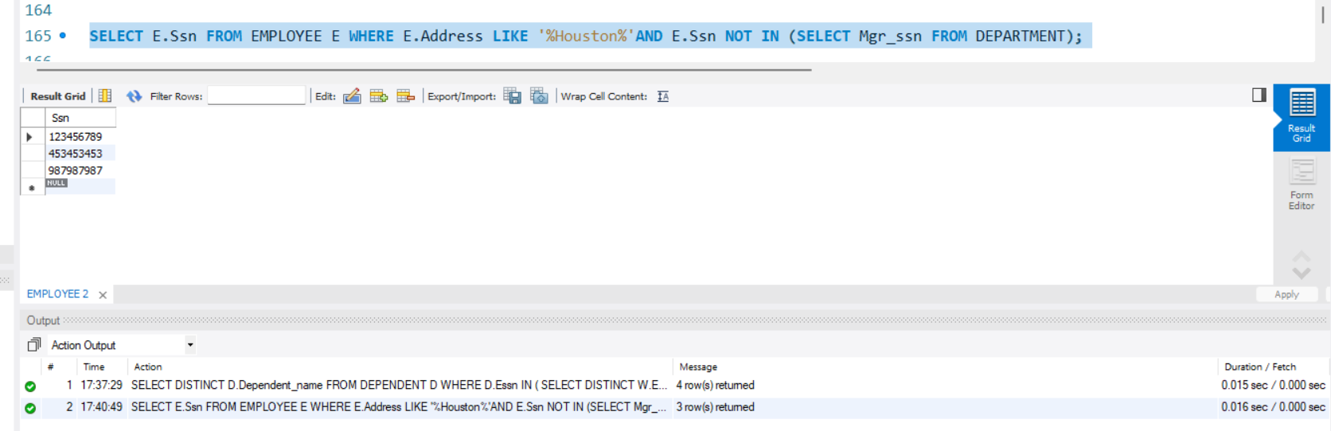

1. **Show the names of the departments and the names and salaries of the male workers n these departments.**

select distinct E.Ssn from EMPLOYEE as E join DEPARTMENT as D ON D.Mgr_ssn != E.Ssn where E.Address Like '%Houston%';

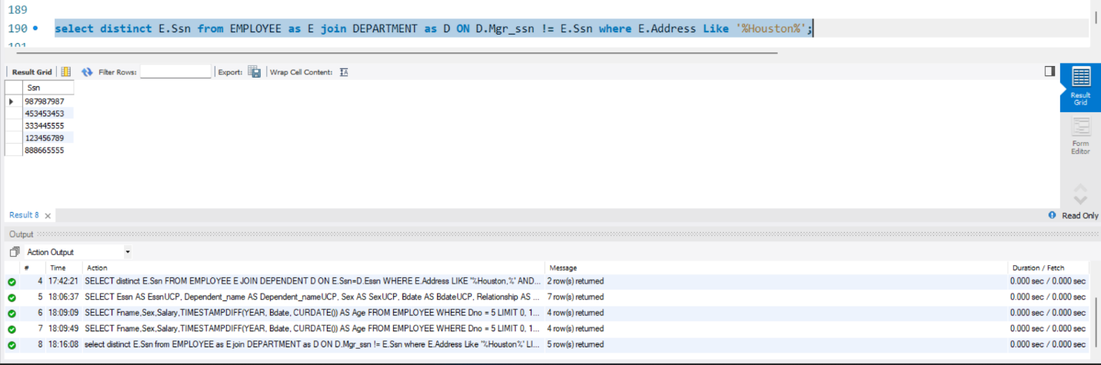

1. **Show the names of the employees along with the names of their supervisors.**

SELECT E.Fname ,E.Lname,S.Fname ,S.Lname FROM EMPLOYEE E JOIN EMPLOYEE S ON E.Super_ssn = S.Ssn;

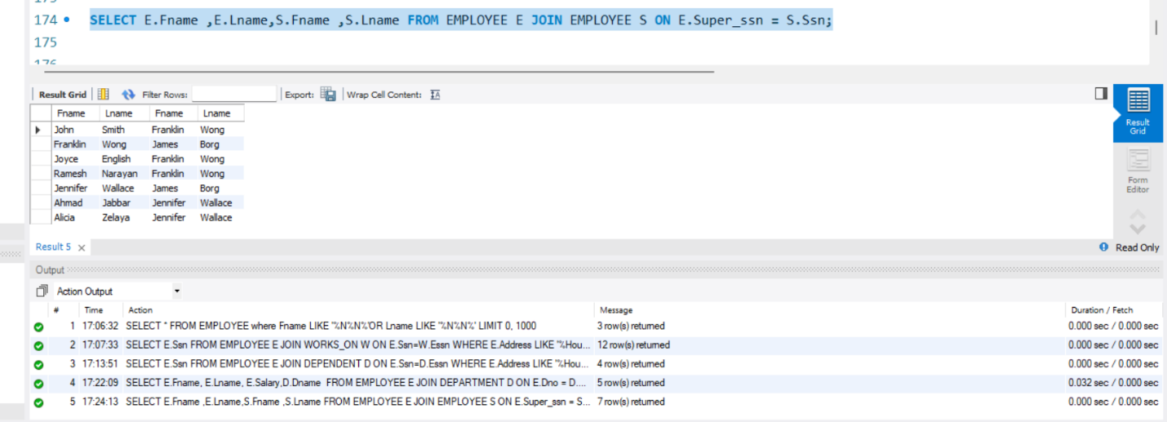

**25. Show the name of the dependents whose parents work on some project located in Stafford or work for some department with office in Stafford.**

SELECT DISTINCT D.Dependent_name

FROM DEPENDENT D

WHERE D.Essn IN ( SELECT DISTINCT W.Essn FROM WORKS_ON W JOIN PROJECT P ON W.Pno = P.Pnumber WHERE P.Plocation = 'Stafford'

UNION

SELECT DISTINCT E.Ssn FROM EMPLOYEE E JOIN DEPT_LOCATIONS DL ON E.Dno = DL.Dnumber WHERE DL.Dlocation = 'Stafford'

);

